Online Shopping Cart
Nicholas Christensen
Colorado State University Global
CSC500: Principles of Programming
Prof. Steven Evans
6/7/2026
Online Shopping Cart
This is the final submission for the Online Shopping Cart Portfolio Project. It pulls together the work from the Week 4 and Week 6 milestones into a single, cleaned application. The ItemToPurchase class stores an item’s name, description, price, and quantity and prints its line total. The ShoppingCart class owns a customer name, a current date, and a list of ItemToPurchase objects, and exposes methods to add, remove, and modify items, count total items, total the cart, print descriptions, and print the full receipt. A print_menu function runs an interactive loop with six commands (a, r, c, i, o, q), re-prompts on invalid input, and exits when the user chooses q. The program is written in Python (version 3.14) and was developed in Visual Studio Code.
Pseudocode
START
DEFINE class ItemToPurchase WITH item_name, item_price, item_quantity, item_description
METHOD print_item_cost(): PRINT 'name quantity @ $price = $total'
DEFINE class ShoppingCart WITH customer_name, current_date, cart_items list
METHOD add_item(item): APPEND item to cart_items
METHOD remove_item(name): FIND by name and DELETE; else print not-found message
METHOD modify_item(item): FIND by name and UPDATE non-default attributes
METHOD get_num_items(): RETURN sum of all item quantities
METHOD get_cost_of_cart(): RETURN sum of price * quantity for each item
METHOD print_total(): PRINT cart and total OR 'SHOPPING CART IS EMPTY'
METHOD print_descriptions(): PRINT each item's name and description
FUNCTION prompt_new_item(): PROMPT for name, description, price, quantity; RETURN ItemToPurchase
FUNCTION print_menu(cart):
LOOP forever
DISPLAY menu options and PROMPT user for choice
IF choice == 'q' THEN RETURN
IF choice not in {a,r,c,i,o,q} THEN print invalid message and CONTINUE
IF 'a': CALL cart.add_item(prompt_new_item())
IF 'r': PROMPT for name, CALL cart.remove_item(name)
IF 'c': PROMPT for name and new quantity, CALL cart.modify_item(temp_item)
IF 'i': CALL cart.print_descriptions()
IF 'o': CALL cart.print_total()
MAIN:
PROMPT user for customer name and date
CREATE cart AS ShoppingCart with the entered values
PRINT customer name and date
CALL print_menu(cart)
END
Source Code
"""
CSC500 - Portfolio Project: Online Shopping Cart (Final)
ItemToPurchase + ShoppingCart classes with a menu-driven interface.
Python 3.14.5
"""

class ItemToPurchase:
"""A single item that can be placed in the shopping cart."""

def __init__(self, item_name="none", item_price=0.0,
item_quantity=0, item_description="none"):
self.item_name = item_name
self.item_price = item_price
self.item_quantity = item_quantity
self.item_description = item_description

def print_item_cost(self):
line_total = self.item_price * self.item_quantity
print(f"{self.item_name} {self.item_quantity} @ "
f"${self.item_price} = ${line_total}")

class ShoppingCart:
"""A collection of ItemToPurchase objects belonging to one customer."""

def __init__(self, customer_name="none", current_date="January 1, 2020"):
self.customer_name = customer_name
self.current_date = current_date
self.cart_items = []

def add_item(self, item):
self.cart_items.append(item)

def remove_item(self, name):
for i, item in enumerate(self.cart_items):
if item.item_name == name:
del self.cart_items[i]
return
print("Item not found in cart. Nothing removed.")

def modify_item(self, modified):
for item in self.cart_items:
if item.item_name == modified.item_name:
if modified.item_description != "none":
item.item_description = modified.item_description
if modified.item_price != 0.0:
item.item_price = modified.item_price
if modified.item_quantity != 0:
item.item_quantity = modified.item_quantity
return
print("Item not found in cart. Nothing modified.")

def get_num_items(self):
return sum(item.item_quantity for item in self.cart_items)

def get_cost_of_cart(self):
return sum(item.item_price * item.item_quantity
for item in self.cart_items)

def print_total(self):
print(f"{self.customer_name}'s Shopping Cart - {self.current_date}")
if not self.cart_items:
print("SHOPPING CART IS EMPTY")
return
print(f"Number of Items: {self.get_num_items()}\n")
for item in self.cart_items:
item.print_item_cost()
print(f"\nTotal: ${self.get_cost_of_cart()}")

def print_descriptions(self):
print(f"{self.customer_name}'s Shopping Cart - {self.current_date}")
print("\nItem Descriptions")
print("-----------------")
for item in self.cart_items:
print(f"{item.item_name}: {item.item_description}")

MENU = """
MENU
a - Add item to cart
r - Remove item from cart
c - Change item quantity
i - Output items' descriptions
o - Output shopping cart
q - Quit"""

def prompt_new_item():
print("ADD ITEM TO CART")
print("Enter the item name:")
name = input()
print("Enter the item description:")
description = input()
print("Enter the item price:")
price = float(input())
print("Enter the item quantity:")
quantity = int(input())
return ItemToPurchase(name, price, quantity, description)

def print_menu(cart):
valid = {"a", "r", "c", "i", "o", "q"}
while True:
print(MENU)
print("\nChoose an option:")
choice = input().strip().lower()
if choice == "q":
return
if choice not in valid:
print("Invalid option. Please choose a, r, c, i, o, or q.")
continue
if choice == "a":
cart.add_item(prompt_new_item())
elif choice == "r":
print("REMOVE ITEM FROM CART")
print("Enter name of item to remove:")
cart.remove_item(input())
elif choice == "c":
print("CHANGE ITEM QUANTITY")
print("Enter the item name:")
name = input()
print("Enter the new quantity:")
quantity = int(input())
cart.modify_item(
ItemToPurchase(item_name=name, item_quantity=quantity))
elif choice == "i":
print("OUTPUT ITEMS' DESCRIPTIONS")
cart.print_descriptions()
elif choice == "o":
print("OUTPUT SHOPPING CART")
cart.print_total()

def main():
print("Enter customer's name:")
name = input()
print("Enter today's date:")
date = input()
cart = ShoppingCart(name, date)
print(f"\nCustomer name: {cart.customer_name}")
print(f"Today's date: {cart.current_date}")
print_menu(cart)

if __name__ == "__main__":
main()
Screenshots
Figure 1
Initializing the cart with the customer’s name and date.
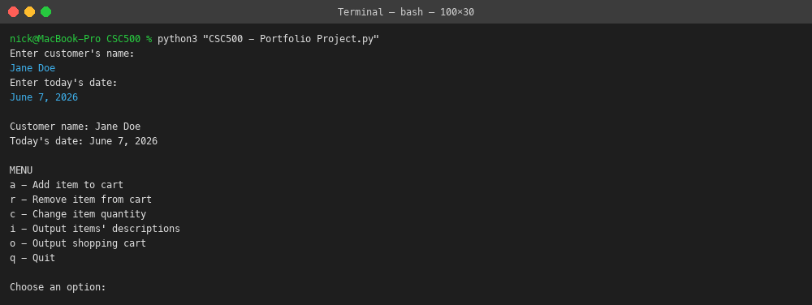
Figure 2
Adding two items to the cart via the menu.
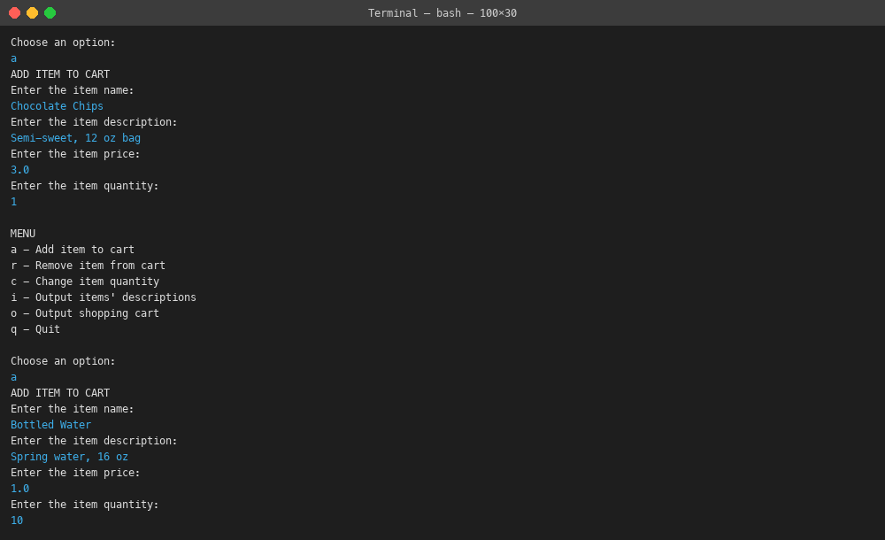
Figure 3
Changing the quantity of an item already in the cart.
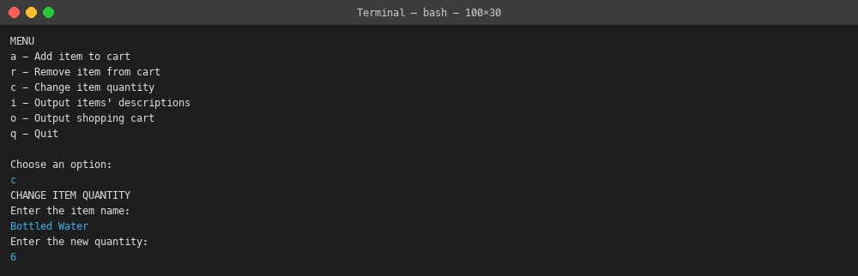
Figure 4
The Output Shopping Cart screen showing the cart totals.
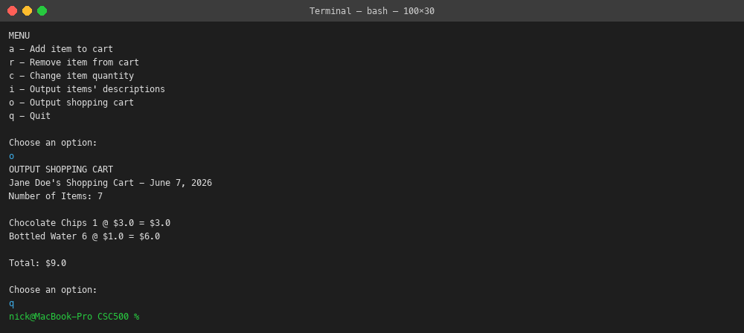
Git Repository
The full project source is available at: https://github.com/nicholaschristensen1-wq/CSC500

